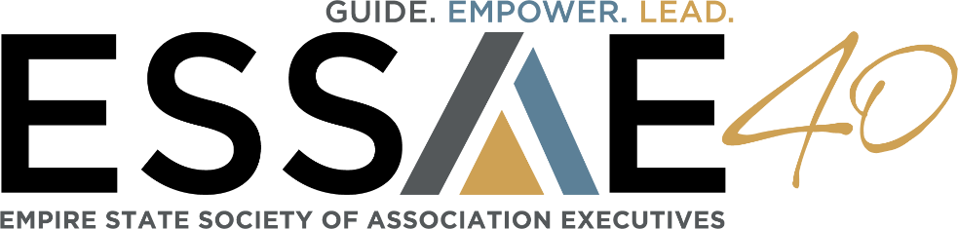
Help Us Preserve Our History! Share Your ESSAE Story!
MEMBER INTERVIEW QUESTIONS
ESSAE is 40! In celebration of ESSAE’s 40th Anniversary, we are conducting interviews with some of ESSAE’s longest-tenured members. We’d like your perspective on ESSAE’s shining moments and how it has influenced industry change over the years; also, how it has benefited you both personally and professionally.
Please take a few minutes to answer the following questions. A few sentences will suffice, but take as much space as you’d like. Alternatively, if you prefer to answer the questions by way of a phone or
in-person interview, please contact 40th Anniversary Committee Member Stephanie Bugos at sbugos@nysba.org.
We also ask that you submit a current headshot to accompany your interview responses. If you have a photo that you would also like to share—please send along! The interviews may be published on ESSAE’s website and/or highlighted in e-newsletters.
Thank you for participating in this important event in ESSAE’s history.
Name and Title: _______________________________________________________________________
Association/Company: __________________________________________________________________
Best Way to Reach You: E-mail: _____________________________ Phone:______________________
- How long have you been in the association industry?
- In its 40-year history,
  - What would you say is ESSAE’s biggest accomplishment?
  - What is ESSAE’s most important contribution to the association community?
  - What would you consider to be the biggest change in the association industry?
- What is one of your best memories of ESSAE?
- What role has ESSAE played in your career?
- What industry trends do you foresee for the upcoming 5-10 years?
- Based on your experience, do you have any advice for up-and-coming association professionals?
- Is there anything else you would like to add?

